ALUMNI NETWORK WEBSITE
@CREATIVITY THINK (9483175986/7019689991)

ABSTRACT:
The Alumni Network Website is a web-based platform designed to connect alumni, students, and professionals from colleges, schools, and professional groups. The system allows users to register, maintain profiles, access job boards, participate in events, and engage in networking activities while providing analytics dashboards for tracking interactions. Administrators can moderate profiles, approve jobs and events, and manage the network ecosystem. Built with Django and Django Rest Framework for backend operations and React with Redux and Leaflet for the frontend, the platform ensures secure communication, efficient data management, and interactive features for meaningful alumni engagement..

INTRODUCTION OF THE PROJECT:
Many educational institutions and professional organizations lack a centralized system for alumni engagement. Existing methods often rely on scattered emails, social media groups, or outdated directories, which limit networking, event participation, and job opportunities. The Alumni Network Website addresses these challenges by offering a unified platform where users can register, update profiles, browse events and job boards, communicate, and track engagement through dashboards. Administrators gain oversight to manage and moderate the network, ensuring quality and relevance of content..

PROJECT OBJECTIVES:

• Provide a centralized system for alumni networking
• Enable users to register, create, and update profiles
• Facilitate browsing and application for job opportunities
• Support event participation and calendar management
• Allow sending messages and connecting with peers
• Provide dashboards for users and admins to track interactions
• Enable administrators to moderate profiles, events, and jobs
• Ensure secure, scalable, and efficient platform management

PROBLEM OF THE STATEMENT:
Traditional alumni engagement relies on emails, spreadsheets, or social media, which lack structure, accountability, and interactivity. Users cannot efficiently track jobs, events, or network interactions. Administrators struggle to manage profiles, approve content, or generate actionable analytics. The Alumni Network Website resolves these challenges by centralizing registration, profile management, job and event boards, messaging, networking features, and analytics dashboards, enhancing connectivity and engagement across the alumni community..

MOTIVATION OF THE PROJECT:
• To provide a centralized digital platform for alumni engagement
• To improve connectivity and networking opportunities
• To maintain structured profiles and activity records
• To enhance access to jobs, events, and institutional updates
• To provide analytics-driven insights for administrators
• To enable moderated and secure content management
• To strengthen the alumni community and professional connections

BLOCK DAIGRAM OF PROJECT:

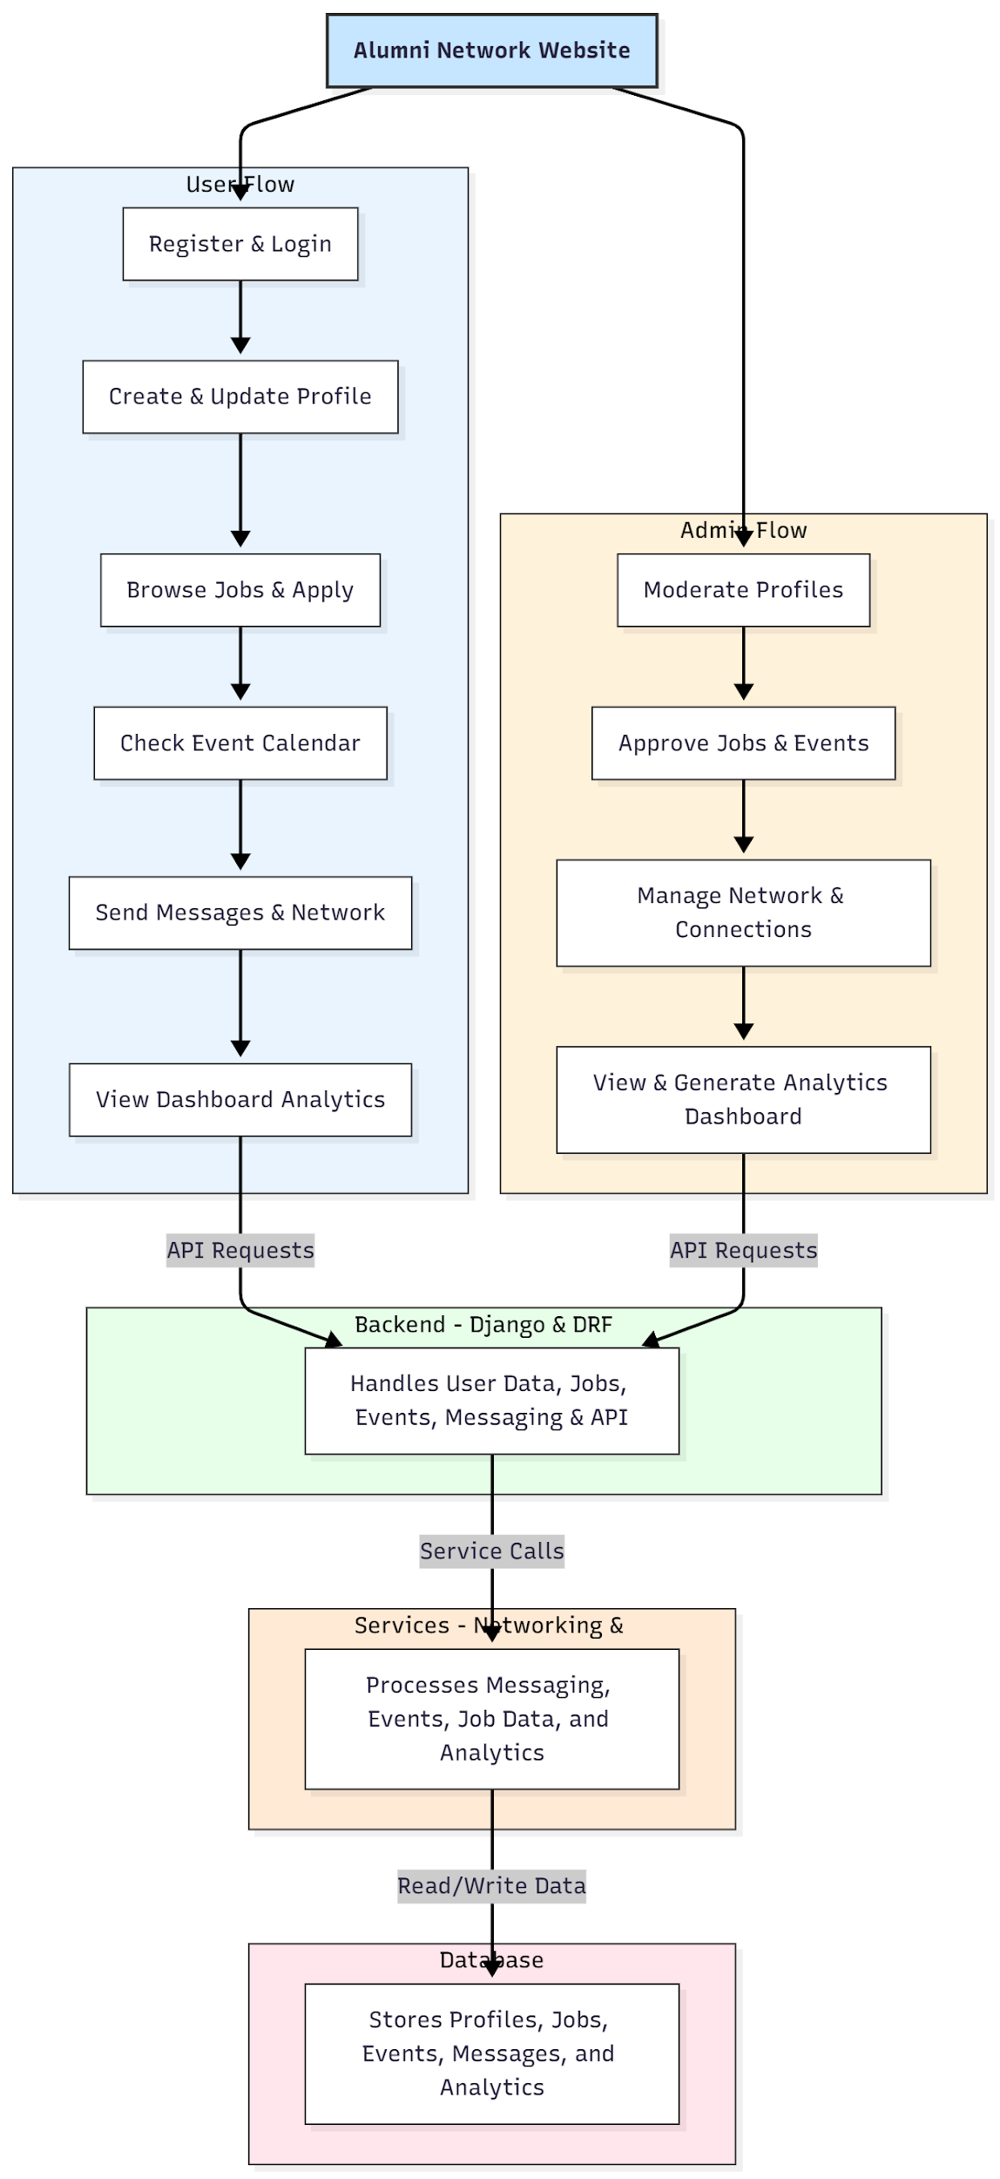

WORKING OF THE PROJECT:
Users begin by registering and logging in to the system. They create and update their profiles with educational and professional information. Users can browse job listings, check upcoming events on the calendar, send messages, and interact with other members via networking features. Administrators moderate profiles, approve job and event submissions, and manage overall network connections. The backend handles all data processing, API requests, and messaging services, while the database securely stores all user profiles, events, jobs, messages, and analytics. Dashboards provide visual insights and operational metrics for both users and administrators..

SOFTWARE REQUIREMENT:
- Backend:
  - Python 3.x
  - Django
  - Django REST Framework
  - SQLite/PostgreSQL
- Frontend:
  - Node.js and npm
  - React.js
  - Axios
- Development Tools:
  - Visual Studio Code
  - Postman (for testing APIs)
  - Git/GitHub (for version control)
- Server/Deployment (Optional):
  - Gunicorn, Nginx, or Heroku/AWS for hosting

ADVANTAGES OF THE PROJECT:

• Centralized platform for alumni networking
• Easy management of profiles, jobs, and events
• Real-time updates for job boards and event calendars
• Interactive messaging and networking capabilities
• Admin moderation for quality control and security
• Analytics dashboards for user engagement tracking
• Reduces dependency on scattered email or social media groups
• Scalable for large institutions and professional organizations

APPLICATIONS OF THE PROJECT:
• Colleges and universities
• Schools and educational institutions
• Professional networks and associations
• Alumni community engagement programs
• Job boards and event management for members
• Networking and mentorship programs

REFERENCES:

- Django REST Framework Documentation — Django Software Foundation. Django Documentation. Available: https://docs.djangoproject.com/
- Django REST Framework. DRF Documentation. Available: https://www.django-rest-framework.org/
- React. React Official Documentation. Available: https://reactjs.org/docs/getting-started.html
- Redux. Redux Documentation. Available: https://redux.js.org/introduction/getting-started
- PostgreSQL Global Development Group. PostgreSQL Documentation. Available: https://www.postgresql.org/docs/
- MySQL. MySQL Reference Manual. Available: https://dev.mysql.com/doc/
- Git. Git Documentation. Available: https://git-scm.com/doc
- Node.js. Node.js Documentation. Available: https://nodejs.org/en/docs/
- Axios. Axios Documentation. Available: https://axios-http.com/docs/intro
- Socket.io Documentation – https://socket.io/docs/

